**Supplemental material for the paper: Homicides increase variation on lifespans in Mexico and its States, 2005-2015.**

**Authors:** José Manuel Aburtoa & Hiram Beltrán-Sánchezb

**Author affiliations:**

a University of Southern Denmark, Odense 5000, Denmark. (jmaburto@health.sdu.dk)

b Department of Community Health Sciences at the Fielding School of Public Health and California Center for Population Research, Center for Health Sciences, Los Angeles, California, USA. (beltrans@ucla.edu)

**Classification of causes of death**

|  |  |  |  |  |
| --- | --- | --- | --- | --- |
| **Category** | ICD 10 | | ICD 9 | |
| **I. Amenable to medical service** I.A. AM-Infectious & respiratory diseases : intestinal infections, tuberculosis, zoonotic bacterial diseases, other bacterial diseases, septicemia, poliomyelitis, measles, rubella, infectious hepatitis, ornithosis, rickettsioses/ arthropod-borne, syphilis (all forms), yaws, respiratory diseases, influenza & pneumonia, chronic lower respiratory diseases I.B. AM-Cancers: malignant neoplasm of colon, skin, breast, cervix, prostate, testis, bladder, kidney-Wilm’s tumor only, eye, thyroid carcinoma, Hodgkins disease, leukemia I.C. AM-Circulatory: active/acute rheumatic fever, chronic rheumatic heart disease, hypertensive disease, cerebrovascular disease I.D. AM-Birth: maternal deaths (all), congenital cardiovascular anomalies, perinatal deaths (excluding stillbirths) I.E. AM-Other: disease of thyroid, epilepsy, peptic ulcer, appendicitis, abdominal hernia, cholelithiasis & cholecystitis, nephritis, benign prostatic hyperplasia, misadventures to patients during surgical or medical care, cisticerchosis. | A00-A09, A16-A19, B90, A20-A26, A28, A32, A33, A35, A36, A37, A40-A41, A80, B05-B06, B15-B19, A70, A68, A75, A77, A50-A64, A66, J00-J08, J20-C50, C53, C61, C62, J39, J60-J99, J09-J18, J40-J47 C16,C18-C21, C43-C44, C67, C64, C69, C73, C81, C91-C95 I00-I02, I05-I09, I10-I13, I15, I60-I69, O00-O99, Q20-Q28, P00-P96 E00-E07, 40-G41, K25-K27, K35-K38, K40-K46, K80-K81, N00-N07, N17- N19, N25-N27, N40, Y60- Y69, Y83-Y84, B69 | | 001-009, 010-018, 32, 33, 37, 137, 020-027, 38, 45, 55-56, 70, 73, 080-082, 087, 090-099, 102, 460-479, 500-519, 480-488, 490-496 153-154, 172-173, 174, 180, 185, 186, 188-189, 190, 193, 201, 204-208 390-392, 393-398, 401-405, 430-438, 630-676, 745-747, 760-779, 240-246, 345, 531-533,540-543, 550-553, 574-575.1, 580-589, 600, E870-E876, E878-E879 | |
| **II. Diabetes** | | E10-E14 | | 250 |
| **III. Ischemic Heart Diseases (IHD)** | | I20-I25 | | 410-414, 429.2 |
| **IV. Lung cancer** | | C33-C34 | | 162 |
| **V. Cirrhosis** | | K70 | | 571.1-571.3 |
| **VI. Homicides** | | X85-Y09 | | E960-E969 |
| **VII. Road traffic accidents** | | V01-V99 | | E810-E819 |
| **VIII. Residual Causes** : HIV/AIDS; suicide and self-inflicted injuries; other cancers and other heart diseases | | B20-B24, U03; X60-X84, Y87.0; C00-D48; I00-I99 if not listed above; R00-R99 | | 042-044; E950-E959; 140-239; 390-459 if not listed above; 780-799 |

Source: Aburto, Beltrán-Sánchez, García-Guerrero, and Canudas-Romo (2016)

**Code and data to reproduce results**

Available at <https://goo.gl/tQV6fL>.

**Shinny app for sensitivity and state specific analysis**

Results with starting age 0, available at <https://goo.gl/n9XuDy>

Results with starting age 15, available at <https://demographs.shinyapps.io/LVMx_15_App/>

**Supplemental figures. All figures are own calculations based on CONAPO (2017) and INEGI (2017) data.**

**Figure S1. Age-cause specific contributions to the changes in national life expectancy at age 15 for females. Panel A refers to 1995-2005 and panel B to 2005-2015. Note: Numbers in boxes are age-specific contributions.**

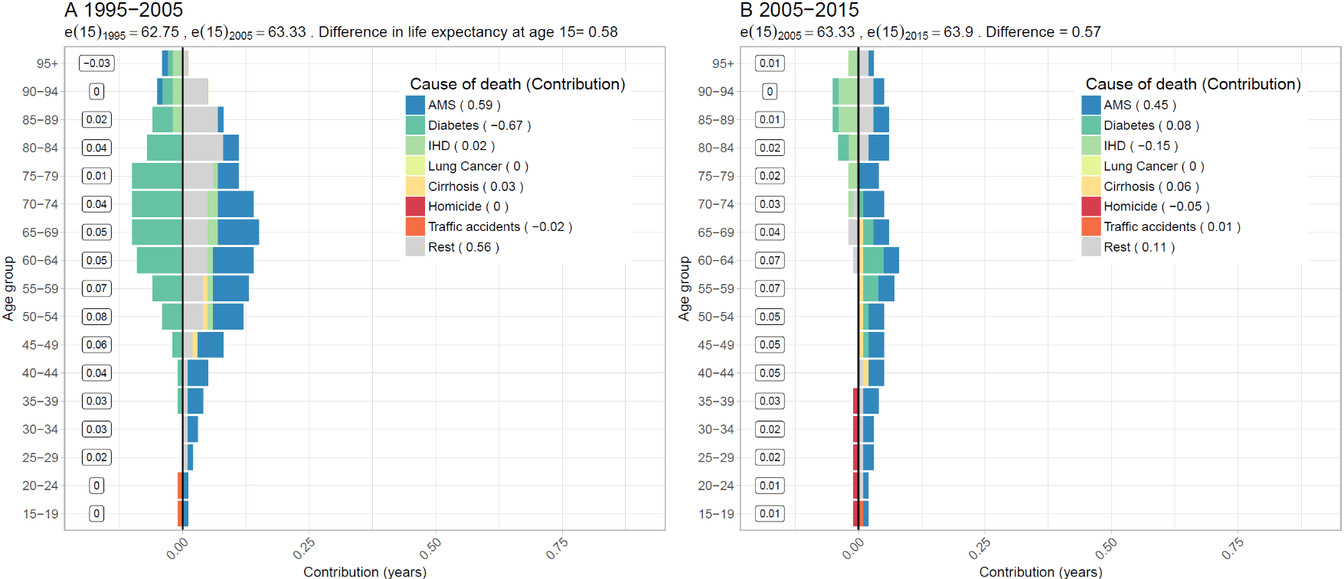

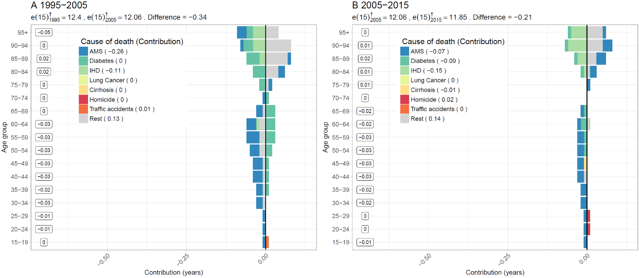**Figure S2. Age-cause specific contributions to the changes in national lifespan variation at age 15 () for females. Panel A refers to 1995-2005 and panel B to 2005-2015. Note: Numbers in boxes are age-specific contributions**

**Figure S3. Changes in female life expectancy (**e15**) (panel A) and female lifespan variation at age 15 () (panel 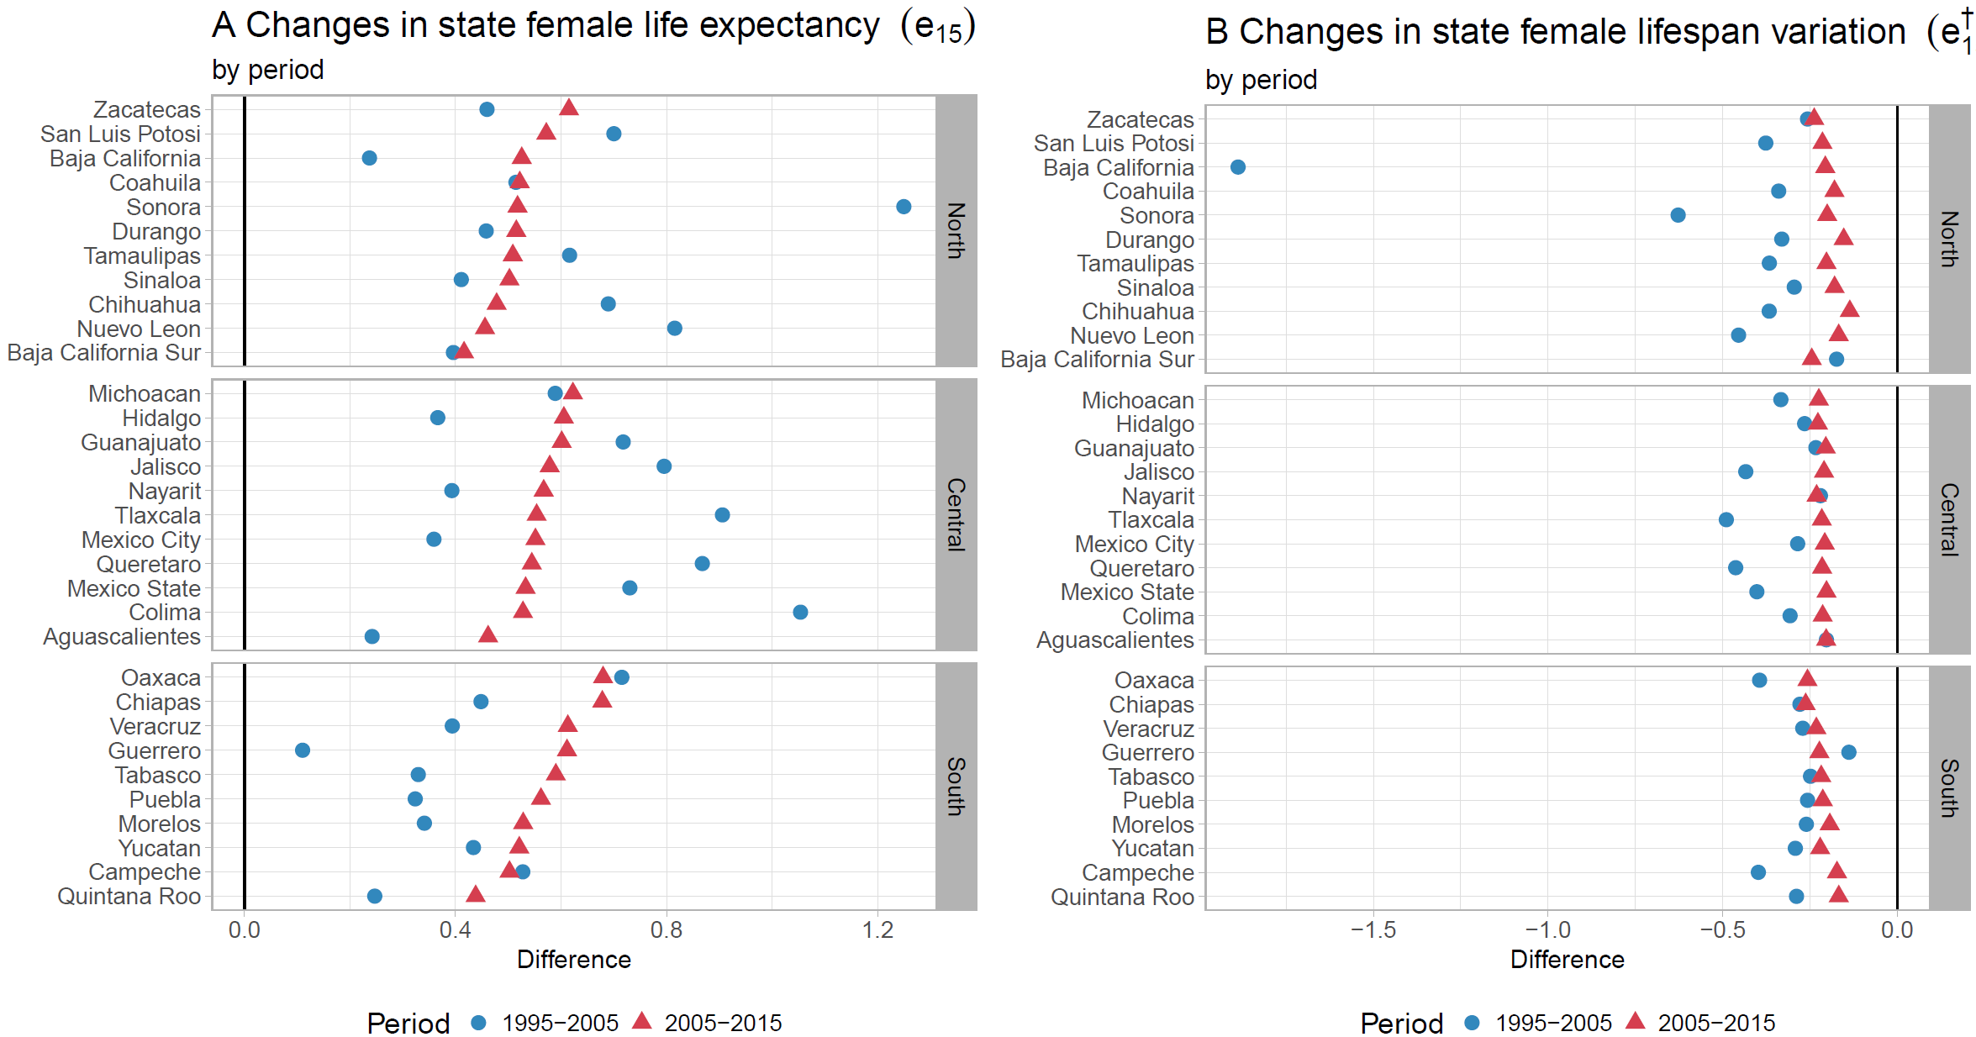B) by state for the periods 1995-2005 and 2005-2015**

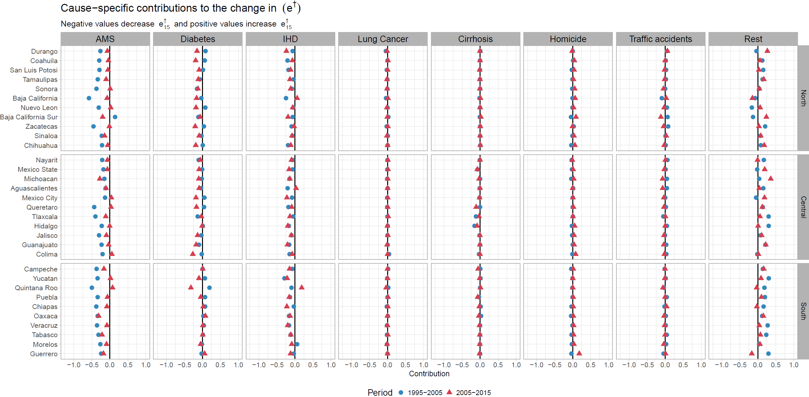**Figure S4. Cause-specific contributions to changes in female lifespan variation at age 15 () by state for the periods 1995-2005 and 2005-2015.**

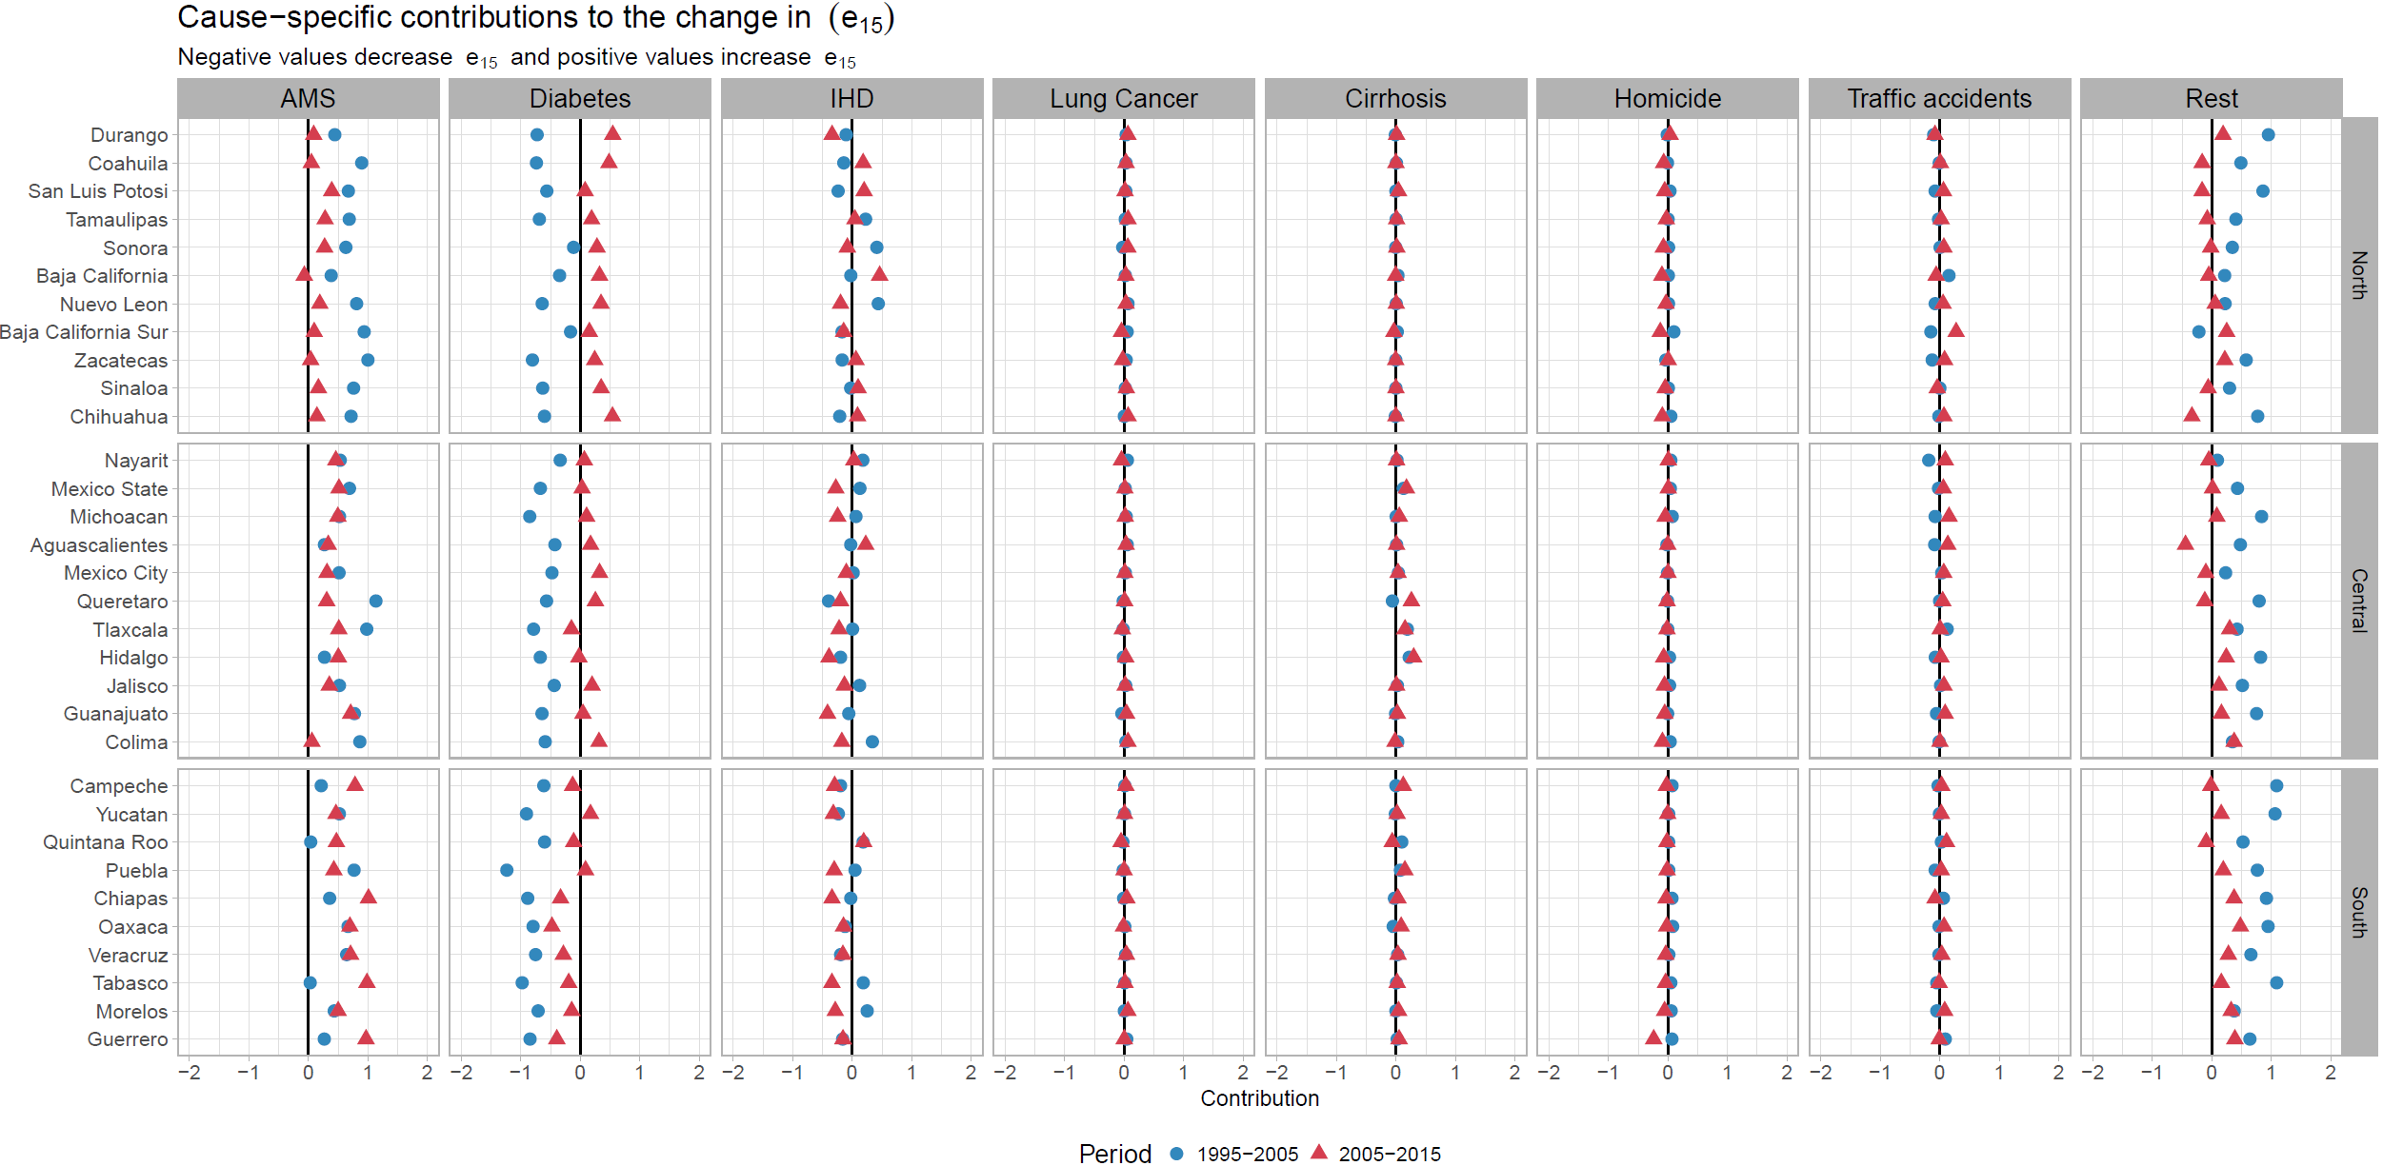**Figure S5. Cause-specific contributions to changes in female life expectancy at age 15 () by state for the periods 1995-2005 and 2005-2015.**

**Figure S6. Cause-specific contributions to changes in male lifespan variation at age 15 () by state for the periods 1995-2005 and 2005-2015.**

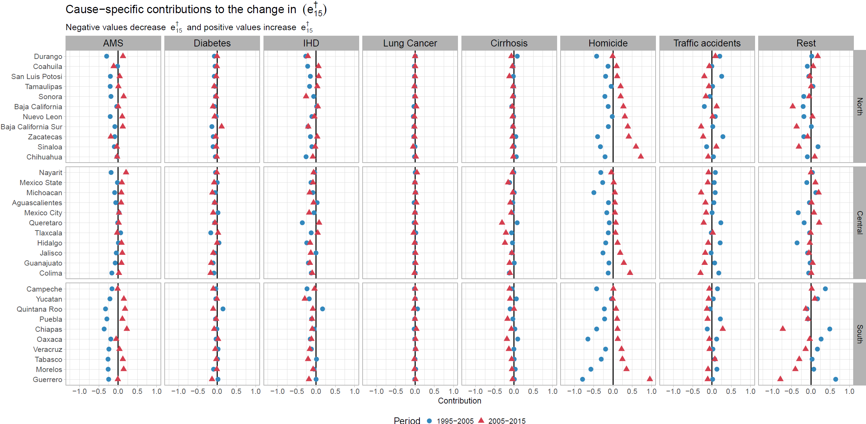

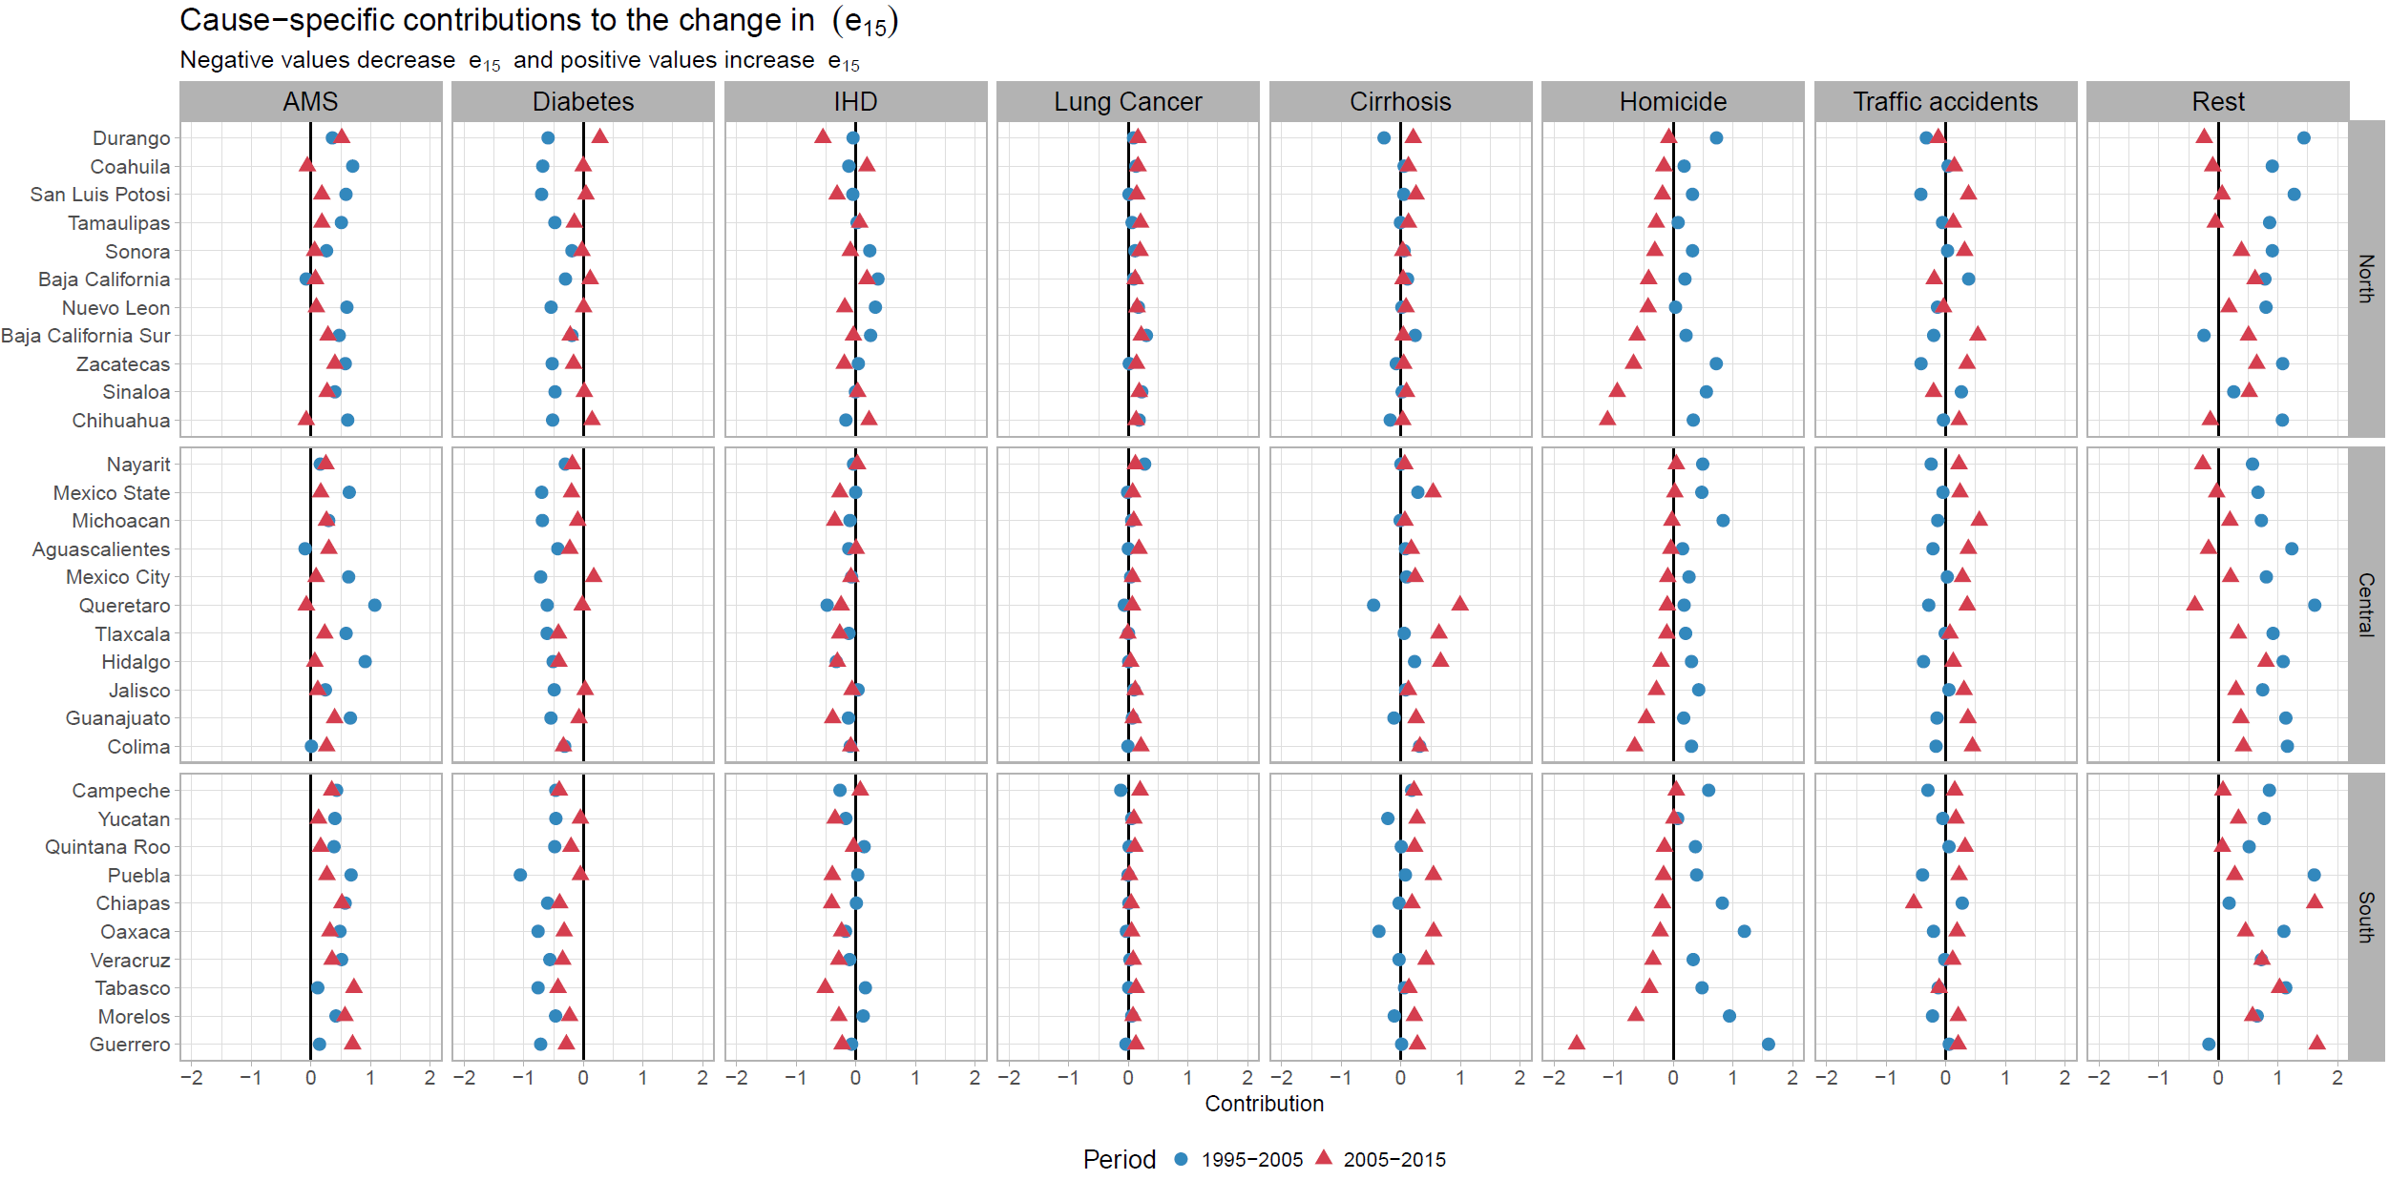**Figure S7. Cause-specific contributions to changes in male life expectancy at age 15 () by state for the periods 1995-2005 and 2005-2015.**

**References**

Aburto, J. M., Beltrán-Sánchez, H., García-Guerrero, V. M., & Canudas-Romo, V. (2016). Homicides in Mexico reversed life expectancy gains for men and slowed them for women, 2000–10. *Health Affairs, 35*(1), 88-95.

CONAPO. (2017). Mexican Population Council: Population estimates. Retrieved from <https://datos.gob.mx/busca/dataset/activity/proyecciones-de-la-poblacion-de-mexico>

INEGI. (2017). National Institute of Statistics: Micro-data files on mortality data 1995-2015. Retrieved from <http://www.beta.inegi.org.mx/proyectos/registros/vitales/mortalidad/default.html>